IT432

Spring 2021

Daniel Freburg

**IT432 Final Project**

**Helpful Tips**

Introduction

Before beginning the IT432 final project read the following helpful tips. The helpful tips address a few problems encountered before beginning the final project.

**1. Check for all hardware included!!!!**

The Raspberry Pi is used by students each semester and might not have all hardware included.

The Raspberry Pi kit should have:

**1. Raspberry Pi**

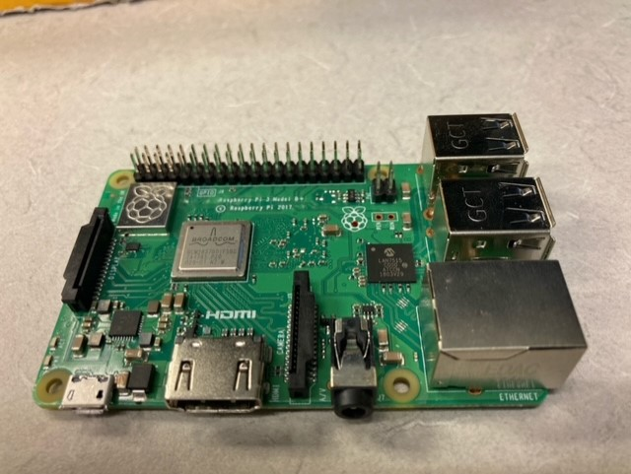

**2. Micro SD card**

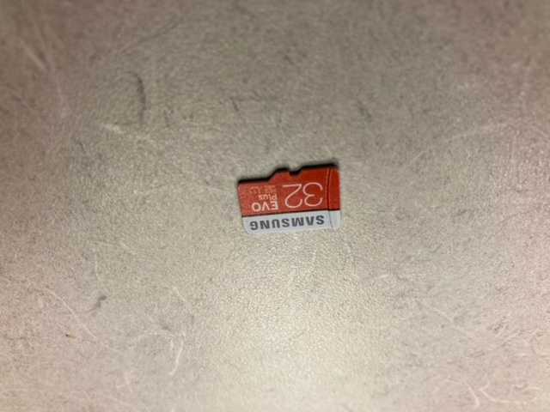

**3. Power cord**

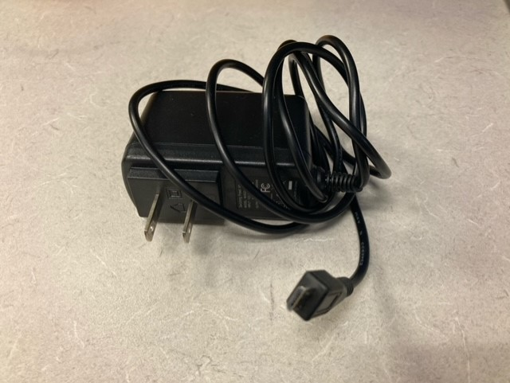

**4. HDMI cable**

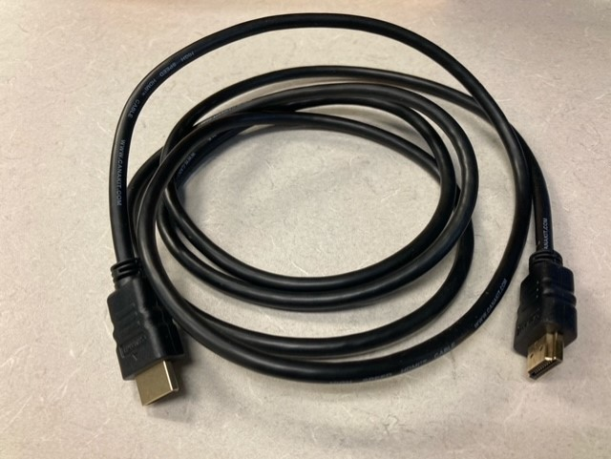

2.  **DO NOT connect the Raspberry PI via the HDMI cable to your laptop**

Most laptops have a HDMI port and a settings for HDMI connections. Most laptops HDMI ports are for output…. not input; so the Raspberry Pi connection will not display onto your laptop screen.

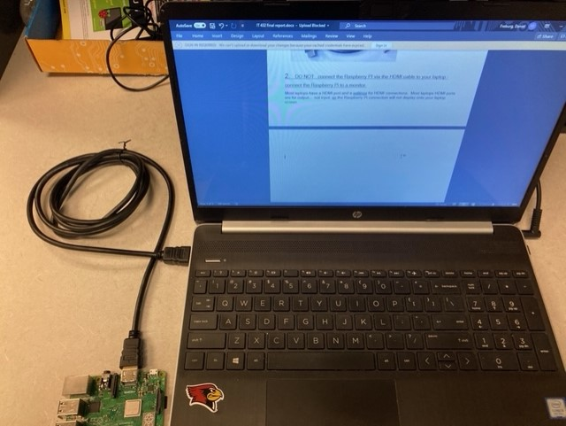



Connect the Raspberry Pi to a monitor!!!

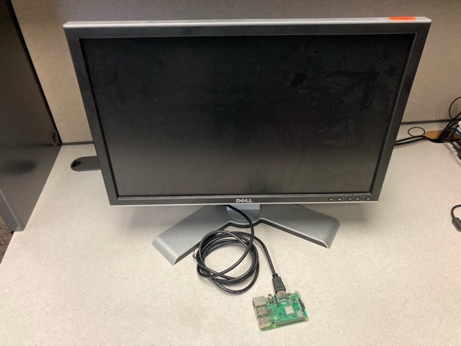

Conclusion

The Raspberry Pi does not get power from a USB to USB connection the way an Arduino gets power. To view the Raspberry Pi output the Raspberry Pi must be connected to a monitor, and most laptop HDMI ports are output ports and not input ports. Hopefully these helpful tips will assist you with a successful start to your IT432 project! *( I started without a power supply….. thinking the Raspberry Pi would get power by a USB to USB connection ??? and connected the Raspberry Pi to my laptop HDMI port and was wondering why no Raspberry Pi output was being displayed ??? )*

Interesting news

<https://kinsta.com/blog/google-cloud-vs-aws/>

<https://cloud.google.com/docs/compare/aws/>